06.04 - Recurrent Defects
Process Design & AMOS Configuration Document
Purpose
This Process Design document is provided to Key-Users to record their key decisions regarding the AMOS Process design and the required AMOS configuration.
It is updated throughout the Project Definition Phase and used as the baseline for the Final Acceptance prior to Go-Live
Revision
Author, Name | Date | Notes
DICH | 04.09.2024 | Initial Version
FDEL | 27.06.2025 | Aviatar Reference added

Table of Contents
1. Process Overview & Objectives 3
2. Regulatory References 3
3. Definitions & Glossary 3
4. Process Tasks 4
5. Process Dependencies 4
6. Process Flow 5
7. Process Design Questions 6
8. Data (Source) Mapping 7
9. Other Software Used 7
10. AMOS Configuration 8
a. Basic Data 8
b. Parameters 8
c. Workflows 8
d. Scheduled Tasks 8
e. API’s & Interfaces 8
11. Annex – Additional Info 9

Process Overview & Objectives

Process General Description:
In this process you collect, analyze, and investigate recurrent defects occurring during Aircraft Operation.
This can be done for single aircraft, types of aircraft or the complete fleet.
Main Process Objective (Outputs & Outcomes) :
The Main Objective of this Process is to improve Aircraft reliability and Aircraft availability.
Therefore, you can create out the analysis, documents like Experience Sheets or Reliability Reports and help Maintenance during Troubleshooting recurrent defects with advice from previous experiences with the defect.

Regulatory References

The following regulatory references were identified for this process:
- EASA Annex I (Part-M) M.A.302 (f):
For complex motor-powered aircraft, when the maintenance programme is based on maintenance steering group logic or on condition monitoring, the aircraft maintenance programme shall include a reliability programme.
- EASA Annex I (Part-M) Appendix I 7.2.4 (c):
procedures pertaining specifically to the CAMO such as customised software utilisation, reliability monitoring, use of the aircraft technical log system, and interoperability provisions.

Definitions & Glossary

Key-Words | Explanation
Technical Case Manager | Is the tool in AMOS to manage problem cases concerning single aircraft or complete fleet.
Event Tracking | Module in AMOS where the Maintenance Controller track reported pilot and maintenance problems.
Experience Sheet | Experience Sheets are the outcome of the troubleshooting process. For errors which keep recurring, the engineering department sets up experience sheets for the fault-finding process for similar events in the future to make them visible as helpful information source within the trouble shooting process for a mechanic in several AMOS programs, e.g. Workorder, Event Tracking.
Severity Factor | The Long-Term Severity Factor needs to be defined in APN574 to support the trouble-shooter in his task of finding out where the main problems are or what has been causing more flight irregularities during a certain period.
Experience Sheet | Experience Sheets are the outcome of the troubleshooting process. For errors which keep recurring, the engineering department sets up experience sheets for the fault-finding process for similar events in the future to make them visible as helpful information within the trouble shooting process for a mechanic in several AMOS programs, e.g. Workorder, Event Tracking.

Process Tasks

Business Process Task / Actions / Activities :
- Identifying that defect is recurrent. For this APN 1, APN 649 or APN 432 can be used. It is also possible to get this information from a mechanic, planner, flight crew or engineer.
- Create a new technical case, perform analysis, and collect events in APN 490.
- Develop an experience sheet in APN 217 with all information’s and advice’s to solve this defect.
- Publish experience sheet when finished and approved.
- Monitor defect and adjust experience sheet if necessary.

Process Dependencies

The following process dependencies were identified for this project:
- 01.07 Reliability
- 01.03 Maintenance Programme
- 01.04 SB & AD Assessment
- 08.02 Performing Maintenance

Process Flow
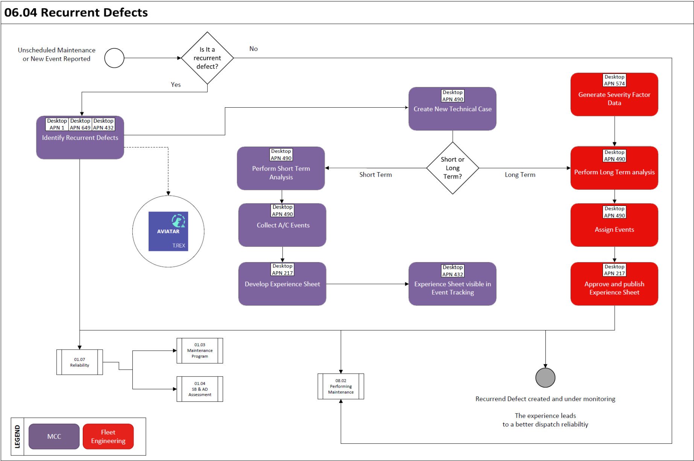

Process Design Questions

# | Question | Answer
1 | Who is in charge to analyze repetitive occurrences?
2 | How is the analysis process defined? Which documents do you use?
3 | How do you classify or differentiate between a short term and a long-term trouble shooting case?
4 | How do you follow up solutions which were implemented?
5 | Who will be in charge of creating Experience Sheets?
6 | How are Experience Sheets rolled out?

Data (Source) Mapping

Data Sources | Description | Volume / Manual / Automatic / Static / Dynamic
-Nil-

Other Software Used

Other Softwares | Used by: | Description
Aviatar | MCC, Fleet Engineering | T.REX Module

AMOS Configuration

Additional ATA Chapter may be needed for better analysis.

Basic Data

Basic Data Table | Notes
ATA Chapter

Parameters

Parameter Code | Parameter Name | Notes
1276 | ROI MAINT. COST FORMULA
1277 | ROI INT. COST FORMULA
1225 | ACTIVATE CASES IN AET

Workflows

Workflow Number | Workflow Name | Notes
78 | Review date due

Scheduled Tasks

Scheduled Task Reference | Frequency | Notes
CaseReviewNotificationTask | daily

API’s & Interfaces

Reference | Direction | Trigger | Frequency
-Nil-

Annex – Additional Info

-Nil-

